Lecture 1. The role and place of the font in history.
1. Brief history of fonts
Throughout history, man has mastered new ways of transmitting information. At first, these were drawings that repeated plots taken from life, and then texts encrypted with conventional images. Fonts have evolved over thousands of years, from hieroglyphs to modern abstract symbols.
The history of the emergence of writing plays an important role in the history of the development of culture, the history of the development of communication between people, the history of the development of language, the development of humanity as a whole. The history of the development of the font begins with the appearance of hieroglyphs - this is how, over many years and, as we know, centuries, the first attempts were made to transmit information between people and to preserve information.
When did hieroglyphs appear?
Historians believe that the Chinese character system is thousands of years old, although the exact time when Chinese writing in the form of characters appeared is constantly being clarified.
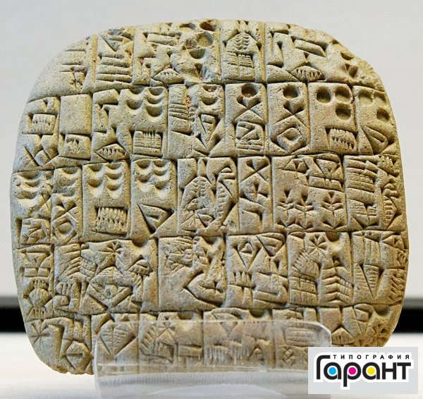
At the same time, researchers believe that, for example, the writing of the Peiligan culture arose before our era. It is believed that the Neolithic writing culture originated 6-7 thousand years BC.
Similar writing systems existed not only in China, but also in India and Egypt. In the writing system using hieroglyphs, each word was designated by a separate symbol.
What is a review and when did it appear?
History dates the emergence of cuneiform writing to 3300 BC. Historians have discovered an inscription in the form of lines left on surviving clay tablets. For example, ancient Persian cuneiform writing was known, one of which was deciphered by the German philologist Georg Grotefend in the 19th century.
Cuneiform writing is a writing system based on a complex of cuneiform signs. This system first appeared among the Sumerian peoples, the inhabitants of Southern Mesopotamia, and then spread to many western regions of Asia. Cuneiform writing was also used by the Hittites, Babylonians and Assyrians. Service life of the system-page hour. XXIX-I century. Initially, the Sumerians used a hieroglyphic writing system and recorded many words using pictures, but since the main writing material was clay tablets, using pictures was labor-intensive and inconvenient, all the signs were simplified to strokes. Each symbol represents a syllable or word. Initially, there were about a thousand of them, but later the number of signs was reduced to 600. Words were written in two main directions - from bottom to top and from left to right. The center of Sumerian writing was probably the sacred city of Nippur (in the territory of modern Iraq), which was also the main temple, the sanctuary of the god Enlil. The largest number of clay tablets were found during excavations at the site of Nippur. Some of them contain special instructions for secretaries. The Sumerians recorded mainly information about economic needs, and from 2.6 thousand BC they began to develop a literary tradition.
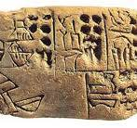
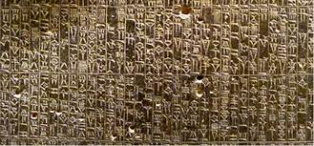
In 1802, the German philologist Georg Grotefend was the first to decipher the cuneiform script containing the well-known names of the ancient Persian kings Darius and Xerxes. Assyriologist George Smith, the first translator of one of the most ancient works of Sumerian literature, the Epic of Gilgamesh (the translation was published in 1872 under the title Chaldean Ideas on the Flood), also achieved significant heights in reading cuneiform texts.
How did nomads invent the alphabet?
Turkologists such as Evgeny Polivanov and Nikolay Aristov, as well as researchers such as Sarsen Amanzholov, argue that "in the Eurasian world, it is obvious that written culture arose in regions bordering nomadic civilizations."
True. Writing arose as a sign expressing the property rights of nomads. The property of a nomad consists of movable and transportable livestock, such as horses and sheep. Each clan invented and printed a special symbol to indicate its property. Historians believe that property branding is a trend that arose towards the end of the Bronze Age. Because it is said that only at this time the number of wolves increased by four. Moreover, the symbols worn by the tribes were later systematized into letters and turned into an alphabet. It is worth noting that one letter in the Turkic rune does not represent only one sound. It also serves as a line drawing of the concept. For example, the letter "L" is written as "Y". It is usually given the meaning of a pillar. After all, it is a symbol of the Kazakh tribe Baganaly... In fact, if you look at the Kazakh tribal symbols, you get the impression that each tribe took its letter from the proto-Turkic alphabet.
Runic writing came to Scandinavia along with a runic stone imprinted on a cow.
Scientists call the alphabet created from these nomadic symbols the Turkic runic script. The introduction of the concept of runes into science is associated with the capture of the Sheveds by Russian troops during the Battle of Poltava. In particular, the German scientist who served the Russian government, D. Messerschmidt and the Swedish prisoner of war officer I. Strahlenberg who accompanied him. Tsar Peter wanted to use their knowledge and skills to develop Siberia. Arriving in Altai and walking along the Yenisei, they saw inscriptions on stones and boulders. It was called "runic writing" because of its similarity to the Scandinavian runic script. Although the name was not entirely accurate, it turned out to be appropriate, and this name was fixed in science. "Rune" is a German word. It means secret, sacred.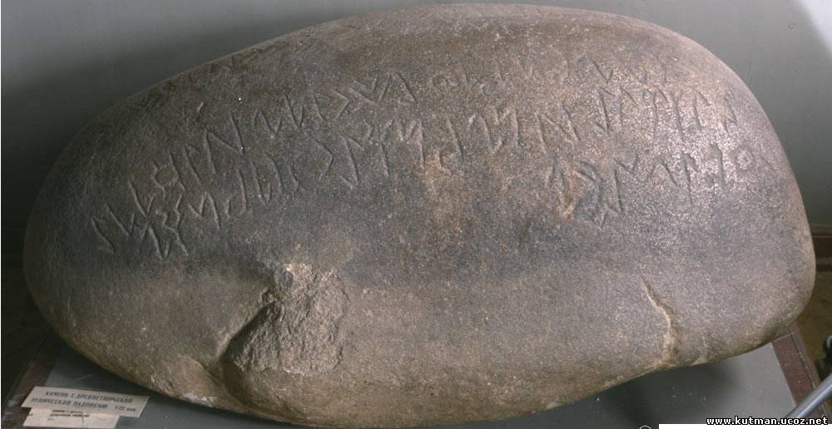
When later German-Swedish officers arrived in Europe and began writing scientific papers, interesting data emerged. Some letters of Scandinavian runic inscriptions were similar to the Turkic runes of Yenisei and Siberia. In such a situation, it is natural to ask who learned from whom. Thomsen and other historical linguists studied this question and found that the runic script was brought to Scandinavia. Who do you think brought it? The modern Finnish nation. If you look closely, these people now live on the Scandinavian Peninsula, but they are originally from Asia. It is known that in the Bronze Age they inhabited the Ural Mountains and the Torgai steppe. Archaeological evidence suggests that these Finno-Ugric tribes marked their herds with signs similar to the runic script. The Finno-Ugric peoples, who were cattle breeders under the leadership of the Sakas and Huns, retreated and went to Scandinavia. It is said that it was through the Finns that the locals learned about iron and runic writing from the East.
In the proto-Turkic cuneiform, one letter could not only denote one sound, but also describe an entire concept or object. In other words, you can read the runic script in letter form and get one meaning, and study it in symbolic form and get a completely different meaning. Perhaps this is why the Germans called this writing "rune", which means secret, magical. If you listen to the legends of the ancient Vikings, a giant named "Odin" lost one eye trying to read this "rune". We read the inscriptions of the "Blue Turks" in alphabetical order. We understood what he wrote. But if we read the symbols of each letter, does it tell a completely different story? Maybe.
Ancient Turkic inscriptions
Old Turkic inscriptions or Orkhon-Yenisei inscriptions - c. 5th century. - Stone inscriptions of the Turkic tribes of the 10th century. Orkhon-Yenisei monuments were first discovered along the Orkhon River (during the Second Turkic Khaganate), and later in the upper reaches of the Yenisei River (during the Kyrgyz Khaganate). It is sometimes called runic writing, which is similar to German runes (some symbols are similar in shape, and the phonetic value is similar). Asian-Turkic runes were developed in the 8th century on the basis of the Sogdian script. is considered to have been made earlier. Its alphabet contains about 40 graphemes. A distinctive feature of the Old Turkic runic script is that it contains several pairs of independent letters to denote the main velar and palatal consonants. The secret of the Old Turkic runic script was revealed in 1893 by V. Thomsen. The first translations of the Orkhon monuments were made in 1894 by V.V. Made by Radlov.
The alphabet of the "Golden Age" (8th century AD) included 38 symbols and a hyphen. The writing direction is vertical, from right to left. Thin and thick vowels are not distinguished in writing, and some consonants are designated by symbols indicating whether they are followed by a thin or thick vowel. The hyphen is placed between words, not at the end of a sentence. The register is not taken into account.
History of steppe writing
BC. In the 8th century, the Brahmi and Kharoshi scripts spread across the nomadic steppes. They came from Ancient India. For example, reading short inscriptions from the Hunnic period showed that the word "shanyu" (Mode shanyu) in Chinese inscriptions in the Hunnic language is pronounced as "Sengir". It means "high", "elevated", "lofty" and is found in modern Turkic languages, for example, in Kazakh in such expressions as "Sengir taular" and "Zangar kok". Ancient Chinese, 1000 BC. This is the script that was called the "Hunnic script" in ancient times. Later, in BC. From the 3rd century, Sogdian scripts spread across the steppe. It was founded in the ancient state of Kanly in the 1st century BC. 3 and AD. It was widely used in the 5th century. For example, the "Kultobin inscriptions" found in the south of modern Kazakhstan date back to the 1st century BC. Dated to the 2nd-1st centuries.
The Old Turkic script was mainly used during the times of the Great Turkic Khaganate, the Sine-Turkic Khaganate and the Khazar Khaganate between the 6th and 10th centuries. Its area of ​​distribution extends from the Mongolian-Siberian steppes to Tibet and the regions of Hungary and Chuvashia in Europe. The Old Turkic script in the steppe was replaced by the Old Uighur script. These inscriptions are sometimes called Manichaean. Its distribution was due to the spread of the Manichaean religion. Later, these scripts were replaced by Arabic script, which was influenced by Islam. Later, instead of Arabic script, modern Turkic peoples began to use the Latin and Cyrillic alphabets.
General description of the Old Turkic inscriptions
The Old Turkic script, or Old Turkic alphabet, is a phonetic writing system, that is, it records sounds in words by designating them. Scientists divide the Old Turkic scripts, which spread over a large area, mainly in the 6th-10th centuries, into three groups:
- Yenisei monuments.
- Talas monuments.
- Orkhon monuments.
Except for the location, there are no significant differences in the years of their use and the general use of written signs. However, the dates of writing of the Turkic inscriptions indicate that they gradually spread from the Yenisei-Lena interfluve, Siberia and the Baikal region to the Mongolian steppes, the Orkhon region, and from there to Kazakhstan, Kyrgyzstan and Xinjiang. The writing process and the use of symbols are similar, and the reading is uniform. The Yenisei monuments include inscriptions found along the Yenisei River and in areas of the Tuva, Khakassia, and Altai republics (all Turkic republics within Russia), as well as in the Novosibirsk region and on the Irtysh River in Western Siberia, Russia. It was used and written between the 5th and 7th centuries. The total number of ancient Turkic inscriptions found in this region currently stands at about 150.
Talas monuments. Inscriptions from this region are distributed throughout southern Kazakhstan, Semirechye, Syr Darya, and Kyrgyzstan, with the greatest concentration in what is now Zhambyl Oblast. The period of use was the 8th century. The total number of monuments is about 20.
Orkhon monuments. These include monuments found along the Orkhon, Selenge, and Tola rivers in Mongolia and in the Minusinsk Basin in Russia. The period of use was the 7th-8th centuries. The total number of monuments is about 30. However, the most voluminous and long text records belong to this group. Among them, the monuments "Kutlyg Khagan", "Bilge Khagan", "Kultegyn", "Tonykok", "Kuli Chor" and "Moiyn Chor" are of particular historical value. That is, it can be concluded that the ancient Turkic script was widely used in Siberia, Mongolia, Xinjiang, Kazakhstan, Kyrgyzstan and in the south of Russia in the period from the 5th to the 8th centuries. This historical period (5th-8th centuries) and its vast territory correspond to the territory and era of the Great Turkic Khaganate, the Western and Eastern Turkic, Turgesh, Khazar Khaganates and the Blue Turks (the Second Turkic Khaganate). separated from it. In addition, modern science knows of variants of ancient Turkic writing discovered in the Tibetan region and the European steppes.
Contents of ancient Turkic inscriptions
The secret of ancient Turkic writing was discovered by the Danish scientist Wilhelm Thomsen (since 1898). Later it was translated and studied in detail by Russian Turkologists. In the 20th century, scientists from Turkic countries joined in - Tatar, Uzbek, Turkish, Kazakh, Azerbaijani researchers. Sometimes they are called "runic inscriptions". The reason is that before the secret of writing was revealed, these inscriptions at first glance resembled the writing of the ancient Scandinavian peoples. However, scientific research has determined that these are Turkic inscriptions. Thomsen first read the words "Turk" and "God". The total volume of these works is large. By modern standards, this is a medium-sized book. There is a huge amount of historical, cultural, geographical and political information that gives an idea of ​​​​the life, beliefs, worldview and traditions of the people of that time. The series of historical events, campaigns of the Great Khagans, are described in a beautiful, artistic language in the zhyrau-zhoruk style. Therefore, many researchers classify them as works of art. The inscriptions describe events that took place in the era of the ancient Turks and Blue Turks, and indicate geographical names, names of tribes of that time, as well as their location and area of ​​distribution. Unfortunately, monuments of Turkic writing were mercilessly destroyed during the time of the Manichaean Uyghur Khaganate. The works mainly describe historical events in the Great Steppe between the 5th and 8th centuries, they are presented in an artistic language, with recurring themes and internal dialogues, and are distinguished by compositional integrity. Therefore, if we first define the genre, then this is not a chronicle or a genealogy, but a historical epic. The nature of the letter best reflects the sound features of the Turkic languages, including the patterns of consonants. The writing is distinguished by the fact that it is read from right to left and mainly consonants are indicated. They can be thick or thin, and have individual markings.
Examples of ancient Turkic writing have reached us in the form of "printed letters" carved on stone. There is no information about the form in which it was written. This is due to the fact that the letters that could be written on fabrics and processed leather have not reached us due to the intolerance of these materials. At first glance, a person who sees these inscriptions may think that these are symbols of the Kazakh tribes. That is, the inscriptions consist of "arrow symbols", "moon symbols" and "amulet symbols", as well as "eye symbols", "open eye symbols", "fish symbols", then "comb symbols" and "earring symbols". Orkhon-Yenisei script is a collection of inscriptions in ancient Turkic script found along the Orkhon and Yenisei rivers. Including inscriptions on the tombstones of the famous Bilge Khagan, Kultegin and Tonykok.
Orkhon-Yenisei inscriptions
The Orkhon-Yenisei inscriptions are a historical and cultural monument of ancient Turkic writing. For a long time, its secret was unknown, as was the language it was written in. The Orkhon-Yenisei inscriptions are also called runic inscriptions (in the language of the Scandinavian peoples, the word "rune" means "undisclosed", "secret"). Only in 1893. Only the Danish scientist Thomsen reveals the key to reading the secret writing. Several years later, the Russian scientist V.V. Radlov completely read and translated the inscriptions on large stones found along the Orkhon River. Since the largest monuments of runic writing were found in the valleys of the Orkhon and Yenisei rivers, the writing itself received this name. The Orkhon-Yenisei inscriptions turned out to be lines of poetry carved on huge tombstones installed on the graves of the Khan of the Eastern Turkic Khaganate Bilge and his brother Kultegin. The main themes of the song are independence, prosperity and unity of the country.
The poem "Kultegin" tells eight stories:
1- The Khagan's address to his people,
2- Describes the vastness of the Turkic Khaganate,
3- Military campaigns of the Turks,
4- The story of the conspiracies of neighboring taverns,
5- That participation in the Tabgash tribe is dangerous for the Turks,
6- Regretting the inability of the Turkic people to predict the future,
7- About the Khagan who brought glory to the Turkic people,
8- The main attention is paid to the circumstances that prompted the writing of this monument.
Another monument of the Orkhon-Yenisei inscriptions are the verses on the tombstone of Tonykok. It also contains fourteen lines that provide information about the life of the Turks at that time. The history of the dependence of the Turkic people on the Tabgash, the unification of the liberated Turks, the election of the Khagan, the rise of Elteris as a Khagan under the influence of Tonykok, the threat posed to the Turks by spies from the Oguz state, describes battles with opponents, Tonykok's bravery in repelling the enemy, the conduct of battles, the methods of waging wars by the Turks with various tribes, and also praises Tonykok.
The first reports of the discovery of tombstones with secret inscriptions in the Yenisei Valley were made by N.K. Vidzen, S.U. Remezov, as well as the Swedish officer I.T. Strahlenberg exiled to Siberia, the famous German scientist D.G. Messerschmidt and others. From his articles and letters written at the beginning of the 18th century, we know that he gave. 1893 zhylgy karashany 25-kun Denmark king gylym academy son mazhilisinde Wilhelm Thomsen gylye alemdi dur sіlkіndirgen malimdeme zhasada. Galym Orkhon men Yenisei Ozenderi boyinan tabylgan eskertkishterdegi kupiya zhazudy okudyn kiltin ashkandygyn habarlady. Galymnyn eng aldymen oqygan sozderi “taniri” zhane “turik” degen sozder eken. Wherever academician V.V.Radlov has left, runa zhazuynyn he beske zhuyk arpin anyktap algan food. Arada kop uaqyt otpey, V.V. Radlov Orkhon ozeni boyynan tabylgan ulken tastardagi matindi tolyk okyp, audaryp shykty.
A large-scale study has been published, written jointly by qualified scientists M. Zholdasbekov and K. Sartkozhauly, who have carefully studied the Orkhon inscriptions for many years.
L. N. Gumilev considers the Orkhon inscriptions to be a chronicle written by the Blue Turks "about themselves".
The inscriptions on the stones mainly tell about the Turkic Khaganate, the khagans who ruled it and their exploits. The poems "Kültegin" and "Tonykok" are historical sources designed to provide accurate information about the past. The main idea of ​​the poem "Kültegin" is to present the hero Kültegin as a powerful figure of the Turkic Khaganate. The author of the poem "Kültegin" is Yollygtegin The power of the Turkic Khaganate increased, its territory expanded significantly, and the life of the people improved. The personality of Tonykok occupies a special place in the history of the Turkic Khaganate. He was an adviser to Khagan Elteris, Khagan Bogi and Khagan Bilge. Tonykok is a wise and intelligent old man who takes care of the country. When the Turkic Khaganate was surrounded by enemies from all sides, Tonykok helped the Khagans with his wise advice, witty words and heroic deeds. Among the Orkhon written monuments, the poem "Tonykok" occupies a special place. This poem has a different author, and it is believed that Tonykok himself wrote it. Secondly, these artifacts of runic writing were recognized as works of art based on the original literary tradition of the ancient Turks and possessing all the characteristics of a poetic work. Until recently, there were two conflicting opinions regarding the characteristics of the Orkhon relics. One of them, the relics of Kultegin and Tonykok, was considered to be an accurately recorded history of the Turkic Khaganate, having nothing in common with fiction, including poetry. Among the Orkhon written monuments, the poems "Kultegin" and "Tonykok" are the first examples of Kazakh heroic poems, glorifying valor and patriotism, in terms of their ideological content, compositional structure and artistic depiction.
Ancient Turkic inscriptions
Ancient Turkic writing, monuments of Turkic runic writing - ancient Turkic carved inscriptions and manuscripts of the 7th-9th centuries, various texts in the ancient Turkic alphabet. Through ancient Turkic written monuments, one can learn about the ancient language, history, ethnogenesis, geography, spiritual culture, written traditions, customs and worldview of modern Turkic peoples.
Found areas
The regions where ancient Turkic written monuments have been found include the Yenisei and Lena river valleys in Siberia, the Orkhon, Ongin and Selenga river valleys in Mongolia, the Talas and Syr river valleys in Central Asia and Kazakhstan, and the Irtysh and Ili river basins. In 1889, the Russian ethnographer N. M. Yadrintsev found two unusually large stones with bilingual inscriptions at the mouth of the Orkhon River in Mongolia. It was later discovered that one of them was dedicated to Bilge Khagan (735), and the other to his younger brother Kultegin (732), and its contents were fully disclosed. On one side of these monuments are carved Chinese hieroglyphs, and on three sides are carved written signs resembling "Siberian runes" - mysterious inscriptions found along the Yenisei River (these inscriptions were also called "runic" or "rune-like" due to their external resemblance to Scandinavian runes). As a result of special studies conducted by Finnish and Russian scientists, atlases were published in which versions of the Orkhon and Yenisei monuments (photographs, engravings) were collected and published. Ultimately, the Danish linguist V. Thomsen in 1893 basically correctly identified the sound values ​​of the Turkic runic (Orkhon-Yenisei) symbols, and in January 1894, Academician V. V. Radlov gave the first translation of the runic inscription on the Kultegin monument, made in the Old Turkic language. This scientific discovery laid a solid foundation for the comparative-historical direction of linguistics and the systematization of Turkology. After that, it became clear that ancient Turkic written monuments were not only carved on stones, but also engraved on various objects made of metal (gold, silver, bronze) and clay. The total number of identified Turkic runic inscriptions in Mongolia, Siberia and Asia currently amounts to about two hundred. At the beginning of the 20th century, variants of the Turkic runic script were identified in Eastern Turkestan (8th-10th centuries), recorded on paper in shamanic, Manichaean and Buddhist religious and legal contexts. In 1932, a mysterious runic inscription carved on a wooden stick was found in the Talas Valley. S.E. Malov, H.N. Orkun, A.M. Shcherbak and others. He showed the similarity of the inscriptions on the sticks with the Turkic runic symbols and tried to read them in the ancient Turkic language.
Issyk inscription is a written monument of the Saka era (5th-4th centuries BC). 1970 In a large Saka burial near the city of Issyk in the mountain peaks of the Ili region, the body of a warrior covered in gold and various things were found, including a silver bowl with a mysterious inscription. On its back side, 26 runic symbols are engraved. The value of the monument lies, firstly, in the fact that it proves that the language of the Saka tribes who inhabited the ancient lands of Kazakhstan was an ancient Turkic language, and secondly, in the fact that 2500 years ago, tribes of Turkic origin had an alphabetic script:
The Mogol inscription is an ancient Turkic monument (late 7th century) found along the Orkhon River. The monument is dedicated to Mogilyan, the son of Khan Kutlug (Kabagan), the text of which was written by Yollug-tegin, and its discoverer is N. M. Yadrintseva, first read by V. V. Radlov. The inscription describes the campaigns of Mogilyan, Kultegin and Tonykuk.
The Moyunchur monument is an Orkhon-Yenisei ancient Turkic inscription dating back to 759 AD. a written memorial. It was discovered in Northern Mongolia in 1909. found by G. Ya. Ramstedt. He translated the text of the monument into German and published it in 1913. published. This work was written by N. Orkun into Turkish, Yu. E. Malov 1959. translated and published in Russian. The monument is also called the "Selenga Stone". At that time, the khan of the Uyghur state was Moyun-chur. The text of the monument contains the names of places, people, tribes and nationalities (Uyghurs, Oghuz, Toghyz, Tatars, Kirghiz, Turkesh, Turks, Sogdians, Kipchaks, etc.). The monument tells the story from the perspective of a representative of the Oghuz tribe.
The Orkhon inscriptions are a large collection of literary monuments found along the Orkhon and Selenga rivers in Mongolia on tombstones of the Khan dynasty, dating from the 7th-8th centuries. These are ancient Turkic runic monuments written in It includes Bilge-kagan, Kultegin, Tonykuk, Kulichur, Moyun-chur and other monuments. The monuments and written references to them were discovered and published by N. M. Yadrintsev, V. Thomsen, V. V. Radlov.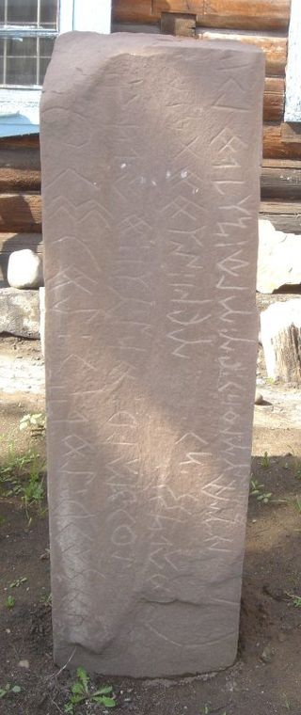
On the Land of Kazakhstan
Over the past thirty years, it has been discovered that there are monuments of ancient Turkic writing on the territory of Kazakhstan. In the Talas region (Zhambyl region), runic inscriptions were found carved on a square stone seal and a half-fragment of a round stone, and in the Ili region (Almaty region), runic inscriptions were found carved on rocks in three places. Runic inscriptions on rings were also found in this region. Runic inscriptions were found on round clay necklaces and jugs found at the site of ancient settlements on the Syr River (Turkestan region). One of the two runic inscriptions on bronze mirrors from the Irtysh region (East Kazakhstan region) was published by A. N. Bernshtam in 1948. Also in 1985, a runic inscription carved on a rock was found in East Kazakhstan, and in 1987, a runic inscription carved on the sole of a seal attached to a lanyard. A runic inscription on a bronze mirror discovered in the Urals (Aktyubinsk region) was published in 1986. K., etc. and Scholars who have made significant contributions to the study of the E. language are V. Thomsen, Radlov, P. M. Melioransky, V. Bang, G. I. Ramsted, A. Gaben, S. E. Malov, V. M. Nasilov, I. A. Bat'manov, A. N. Kononov, J. Clawson, T. Tekin, and others.[3]
Development of writing - the Phoenician alphabet
The development of writing in the form of the Phoenician alphabet began around 1400 BC. True, it was an alphabet consisting only of consonants, but it had 33 letters. This is surprising, since all European alphabets are based on this alphabet.
Development of Phoenician writing - Roman alphabet
The Phoenician alphabet was adopted by the Greeks for thousands of years, who added several vowels (sounds). After that, a font of capital letters appeared, and then of lowercase letters, which gradually turned into the form of writing we are accustomed to and preserved the idea in the form of letters.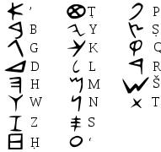
Gutenberg Typography Fonts
Johann Gutenberg's printing presses - raised letters with reverse printing - were essentially the invention of the printing press. The date of Johann Gutenberg's discovery is 1440 in the 15th century. Six centuries ago, Gutenberg invented the printing press and printed letters, and was subsequently called the father of book printing. Moreover, Gutenberg's fonts are considered so useful and attractive in terms of form and execution that they remain relevant to this day.
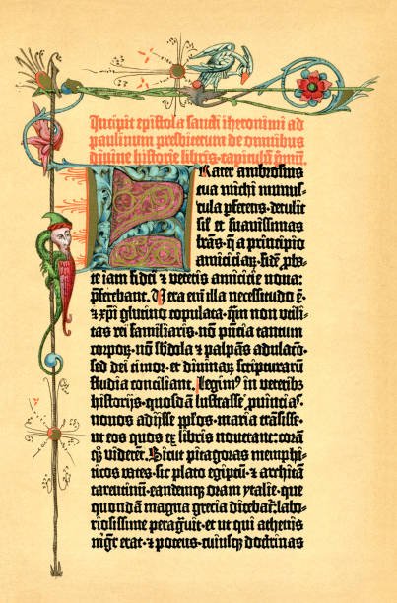
Johann Gutenberg died in 1468, not a very happy entrepreneur, since his mission, above all, was the invention of book printing, which was given to him as a talent. That is why he was remembered for centuries. His printing business quickly spread throughout all European countries and laid the foundation for modern book printing.

Gutenberg typography fonts
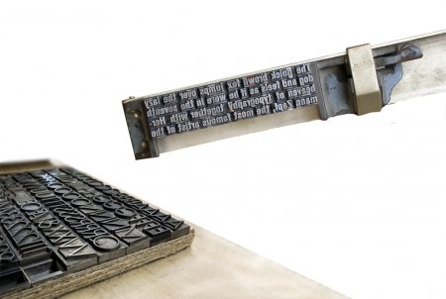

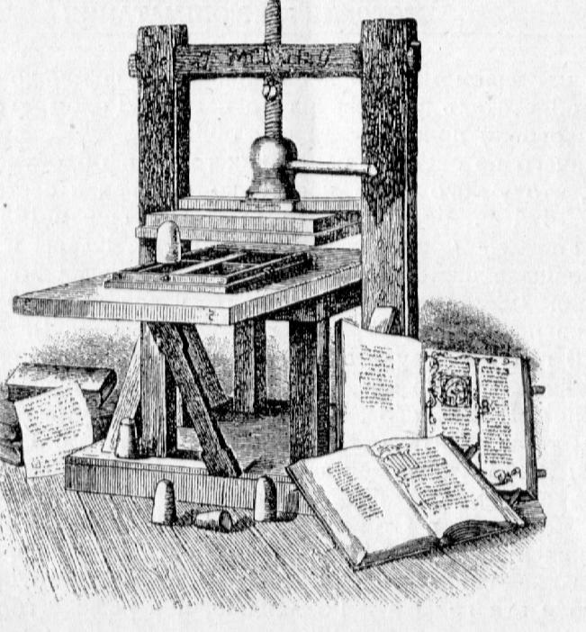 Gutenberg's Printing Press
The history of world writing knows four main types of writing.
? Pictographic (pictorial) writing is the oldest form of writing in the form of pictures (primitive and very conventional).
? Ideographic (hieroglyphic) writing is the writing of the era of the emergence of early statehood and trade. The symbols of this letter are ideograms (hieroglyphs) - signs denoting individual words or entire concepts. This type of writing is called figurative-symbolic. It includes Sumerian cuneiform, Chinese and Egyptian symbols, which over time turned from real copies of objects into conventional symbols.
? Syllable (a syllable is designated by one written sign) - the writing of some peoples of India. In Japan, it was used along with Chinese characters. Syllabic writing was a transition from figurative-symbolic writing to phonemic writing. The first "letters" to designate syllables, and later individual sounds, were invented in Ancient Egypt.
? Phonetic writing is the writing system that underlies the writing of many peoples of the world, whose linguistic features are reflected in the composition of their alphabets. Thus, the Russian alphabet has 33 graphic signs, the Latin alphabet has 23, the Italian alphabet has 21, etc. The symbols of the alphabet differ from each other in their simple, "skeletal" form. The graphic basis of the letters included in the alphabet, a form that does not change regardless of the style, font and other forms, is called a grapheme. The immediate predecessor of the Russian and Latin alphabets is the Greek alphabet, which appeared in the 8th century BC. hour g. It reached relative completeness (graphic simplicity) by the 4th century BC, but the first letter of the alphabet appeared much earlier, around 1000 BC. hour g. It appeared in the 16th century on the Sinai Peninsula. The Semitic tribes living there borrowed a number of ideogram symbols from the Egyptian alphabet (Fig. 1) to denote the first sounds of the names of some objects. The Phoenicians adopted and improved these ideograms. The phonetic alphabet was then passed on to the Greeks, who modified it in accordance with the requirements of their language (in particular, they introduced vowel notations, which were not in the Phoenician alphabet). It is obvious that the structure of the graphemes is historically connected with hieroglyphic images, which is confirmed by the names of some letters of the Greek alphabet.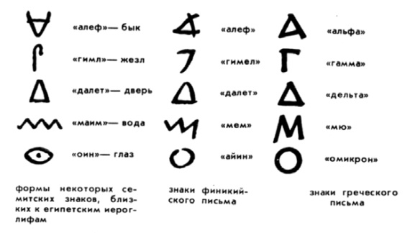
Figure 1. Examples of the evolution of phonetic writing
Over the thousand-year history of the font, the direction of writing letters has also changed. In Egypt, they wrote from top to bottom, the Phoenicians - from right to left, and the Greeks initially wrote in turns: one line from left to right, and the next - vice versa, from right to left. In addition, the letters in even rows were "rotated" (mirrored) relative to the letters in odd rows. Over time, the writing style we are accustomed to developed in only one direction.
2. The history of the development of Latin alphabet fonts
The Latin alphabet is the result of the long-term development of Greek writing, which eventually led to the emergence of Roman writing. The ancient Romans adopted the Etruscan alphabet, based on the Greek alphabet. The Latin alphabet was introduced in the 5th century BC. It was formed before the 1st century, and then over the course of many centuries, its graphic solution evolved. The basic forms were preserved, but the design of the letters changed. These changes were the result of the search for the simplest and most rational letter designs that would ensure ease and speed of writing and reading.
Ancient Greek monumental inscriptions and the early Latin alphabet consisted only of capital letters (maiuscules). Later, in BC. In the 8th–9th centuries, lowercase letters (minuscules) appeared, some of which retained the design of capital letters. Lowercase letters made it possible to write words next to each other and made reading easier due to the resulting superscript and subscript elements.
Let us list the main stages in the development of Latin writing. Capital square script (1st century BC): the proportions of many letters, together with the serifs (horizontal elements at the ends of the strokes of the letter), correspond to a square (Fig. 2); the letters are freely arranged, there are no spaces between words, and the lines are spaced at the same distance as the body of the letter.
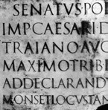
а
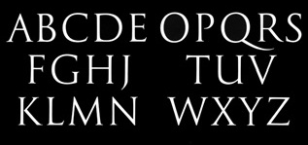
б
Fig. 4.2. Roman capital square inscription: A-text carved on stone, b-letters
Complex rustic font: letters are elongated in a ratio of 5:3; vertical lines are very thin, horizontal lines are thick; The handwriting is continuous, words are sometimes separated by dots (Fig. 3).
Uncial script: usually 12 letters (lines) wide in a column; A letter was 1/12 of an uncia (ounce) – a line. Uncial script is characterized by rounded shapes and relief lines; the proportions of the letters are close to square; hard writing (Fig. 4). Later, a special style appeared for everyday free writing on wax tablets – cursive, which means “running”, “lying diagonally”.

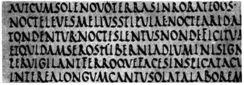
Figure 3. Roman Capital Village Letter
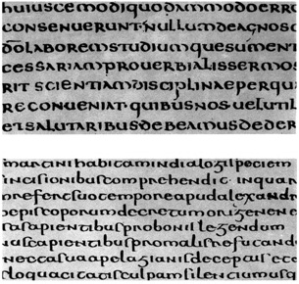
Figure 4. Roman Uncial
Carolingian minuscule (8th century) is the most rational and perfect of all forms of medieval Latin writing (Fig. 5). The alphabet of the era of Charlemagne consisted of lowercase letters, ancient capital letters and Arabic numerals. This alphabet became the basis for all subsequent European fonts, as it was logical and understandable. People needed this type of writing for communication, and over time it developed and changed. Later, Gothic fonts, Renaissance letters and typefaces appeared - but the graphic basis remained unchanged.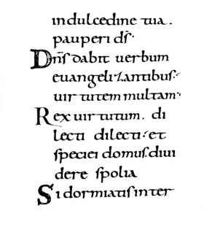
Fig. 5. Carolingian minus
Gothic script (12th–15th centuries): its emergence coincided with the development of the Gothic style. The shape of some symbols, the proportions of letters, the contrast of strokes changed, the distance between lines was reduced, due to which the image of the letter became very dark, which made it difficult to read and write texts (Fig. 6).
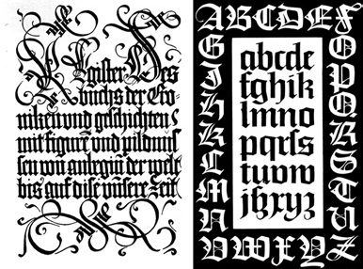
Fig. 6. Examples of Gothic writing
Humanistic writing (antiquarian): Humanists completely revived Carolingian minuscule, using the aesthetic standards of the Renaissance. Taking it for the writing of ancient times, they called it antique (Fig. 7). Antiquarian (Renaissance-antiquarian) arose during the Renaissance; transitional antique coincides in time with the Baroque style; In the era of classicism, new, or classical, antique objects became widespread.
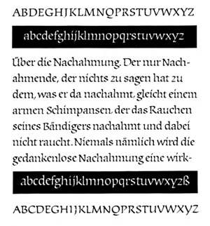
Fig. 7. Humanistic writing (antique)

Egyptian or stroke fonts (Fig. 8) appeared in England at the beginning of the 19th century, initially created for advertising purposes. A distinctive feature is the presence of rectangular serifs corresponding to the thickness of the vertical elements of the letters.
Fonts with cut letters (Fig. 9): the structure of the letters is the same as in antique ones, but there are no serifs at all. Among them, grotesques stand out - non-contrasting fonts.
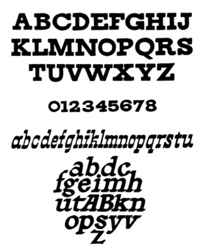

Figure 8. Stripe fonts

References:
1. Russian-Kazakh explanatory dictionary: Linguistics / Editor-in-chief: Doctor of Economics, Professor E. Aryn. – Pavlodar: GOSU "ECO". 2007. ISBN 9965-08-235-9
2. Kazakh language. Encyclopedia. Almaty: Ministry of Education, Culture and Health of the Republic of Kazakhstan, Kazakhstan Institute of Development, 1998. 509 p. ISBN 5-7667-2616-3
3. Sit down. Encyclopedia. – Almaty. Publishing house "Arys", 2005 ISBN 9965-17-272-2Figure 9. Example of truncated font

Character table
Древнетюркский алфавит (период Золотого века)
Application |  |  | Signs |  | Transliteration and transcription
vowels |  |  |  |  | a, e |  | /a/, /e/
 |  |  |  |  | ı, i |  | /ɯ/, /i/
 |  |  |  |  | o, u |  | /u/, /o/
 |  |  |  |  | ö, ü |  | /ø/, /y/
without vowels | connection | with vowels:  (¹) — thick,  (²) — thin  in order |  |  | B¹ | /b/ | B² | /b/
without vowels | connection | with vowels:  (¹) — thick,  (²) — thin  in order |  |  | D¹ | /d/ | D² | /d/
without vowels | connection | with vowels:  (¹) — thick,  (²) — thin  in order |  |  | G¹ | /ɣ/ | G² | /g/
without vowels | connection | with vowels:  (¹) — thick,  (²) — thin  in order |  |  | L¹ | /l/ | L² | /l/
without vowels | connection | with vowels:  (¹) — thick,  (²) — thin  in order |  |  | N¹ | /n/ | N² | /n/
without vowels | connection | with vowels:  (¹) — thick,  (²) — thin  in order |  |  | R¹ | /r/ | R² | /r/
without vowels | connection | with vowels:  (¹) — thick,  (²) — thin  in order |  |  | S¹ | /s/ | S² | /s/
without vowels | connection | with vowels:  (¹) — thick,  (²) — thin  in order |  |  | T¹ | /t/ | T² | /t/
without vowels | connection | with vowels:  (¹) — thick,  (²) — thin  in order |  |  | Y¹ | /ʤ/ | Y² | /ʤ/
without vowels | connection | tek (¹) — Q  tek (²) — K |  |  | Q | /q/ | K | /k/
without vowels | connection | all  with vowels |  |  | -Ç |  | /ʧ/
without vowels | connection | all  with vowels |  |  | -M |  | /m/
without vowels | connection | all  with vowels |  |  | -P |  | /p/
without vowels | connection | all  with vowels |  |  | -Ş |  | /ʃ/
without vowels | connection | all  with vowels |  |  | -Z |  | /z/
without vowels | connection | all  with vowels |  |  | -NG |  | /ŋ/
without vowels | registrations | + vowels |  |  | IÇ, ÇI, Ç |  | /iʧ/, /ʧi/, /ʧ/
without vowels | registrations | + vowels |  |  | IQ, QI, Q |  | /ɯq/, /qɯ/, /q/
without vowels | registrations | + vowels |  |  | OQ, UQ,  QO, QU, Q | /oq/, /uq/,  /qo/, /qu/, /q/ | ÖK, ÜK,  KÖ, KÜ, K | /øk/, /yk/,  /kø/, /ky/, /k/
without vowels | registrations | + without vowels |  |  | -NÇ |  | /nʧ/
without vowels | registrations | + without vowels |  |  | -NY |  | /nʤ/
without vowels | registrations | + without vowels |  |  | -LT |  | /lt/, /ld/
without vowels | registrations | + without vowels |  |  | -NT |  | /nt/, /nd/
hyphen |  |  |  |  | No
(-) — only at the end of the word

